Country Facts Form
Formal Name | THE REPUBLIC OF THE UNION OF MYANMAR |  |  | 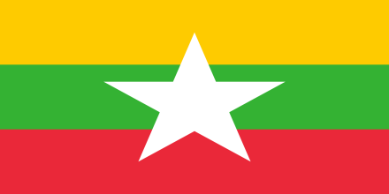
Short Name | MYANMAR
Capital | NAY PYI TAW
Major Cities | YANGON, MANDALAY

Geography
Climate | Tropical climate with three seasons: monsoon or rainy season (July to October), cool season (November to February) and summer or hot season (March to June)
Natural Resources | Timber, Minerals like tin, zinc, copper, tungsten, lead, coal, limestone, precious stones such as jade, ruby and sapphires, oil and natural gas
Time Zone | MMT (UTC+06:30)
Total Area | 676,578 km² | Natural Hazards | Cyclones, Floods, Tsunamis and landslides

People
Population | 51.4 million | Official Language | MYANMAR
Life Expectancy | 64 (Male) & 67.8 (Female) | National Day
Ethnic Groups | 135 ethnic groups
Religion | Buddhism (89.2%), Christianity (5.0%), Islam (3.8%), Hinduism (0.5%), Spiritualism (1.2%) and others (0.2%)

Government
Government Type | Civilian government | President/  King | President
Legal System | Based on English common law

Economy
GDP (purchasing power parity) | $269.996 billion | GDP - PER CAPITA (PPP) | $1,419
Exchange Rate (to USD) | ~ 1200 Kyat / 1 US$ | Unemployment rate | About 4 %
Imports | Petroleum products and crude oil, fertilizer, plastics, machinery, transport equipment, cement and construction materials, food products and edible oil
Exports | Rice, pulses, beans, sesame, groundnuts, sugarcane, hardwood, fish and fish products

